Investigation: Epigenetics Name: _______________________________per__

Read and follow the instructions, click on the appropriate links as needed. Answer all questions on this sheet
Part I. Watch the Epigenetics video (click highlighted link) AND answer the questions below.
- What is the epigenome?
The amount of tags (chemicals) attached to the DNA (genes). Epi- = above

- The video refers to ‘tags’, What do the methyl groups do?
- Inhibit (stop) the transcription machinery
- Causes the genome/ gene to be wrapped tightly (around the histones)

- The “B” tags are acetyl groups, so what do these acetyl tags do?
Unwind the DNA - provides access to DNA for gene expresssion

- Chemical tags, or methylation/acetylation, are influenced by environmental factors and social experiences.

- What are the environmental factors mentioned in the video?
Diet, chemical exposure and medication

- Summarize the rat pup experiment.
When mother rats did pay attention to baby rats, specific genes that helped calm babies were methylated (turned off) and the baby rats became anxious easier.

- Why can identical twins, as they grow older, be so different?
Environmental factors (life experiences, diet, where they live) can lead to differences

Part II. Read the Epigenetics section in Ch.12.3 (p.355) to further support your understanding of the video and help you answer the following questions.

6. Why are genes contained in compact chromatin not expressed?  The chromatin wound too tight that the DNA can not be accessed so genes can’t be read and expressed  7. LABEL methylation and acetlyation ON the diagram to the right. | 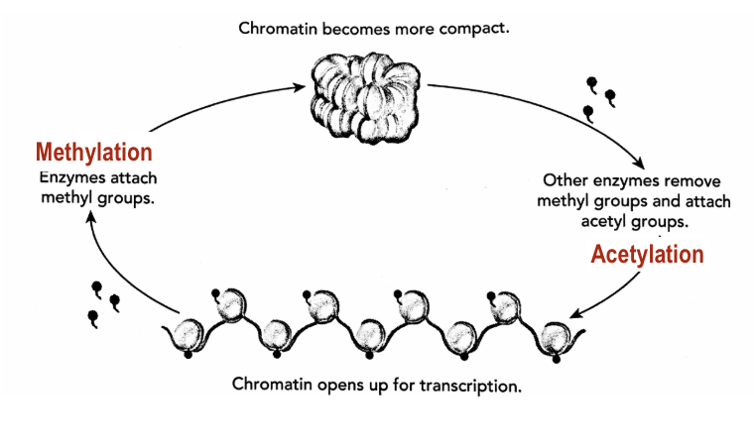

- What changes to epigenetic markers cause chromatin to open up?
Acetyl groups attach to the genome and Methyl groups detach

Read “Environmental Influences” on page 356 of the textbook (Ch 12.3)
- What environmental factors are listed as affecting gene expression?
Temperature, salinity (amount of salt), and nutrient availability

- Summarize the findings about the epigenome of Dutch children born near the end of WWII and how it affected them later in life.
Children born to mother’s who had food shortages had higher rates of obesity, diabetes and cardiovascular disease due to a low amount of nutrients in the womb. Their bodies were adapted to dealing with food shortages even though food became plentiful again.

Part III Go to https://learn.genetics.utah.edu/content/epigenetics/control/ Click on all of the “i” next to each term/box to get a sense of what the interactive is showing you and to check your answers to #2 and #3 above.

- What coded instructions are present in the GFP gene?
DNA are the instructions (which then makes mRNA) to make a green fluorescent protein

- What does GFP do? Why is its presence a good way to determine gene activity?
When GFP is present and active it fluoreses GREEN under UV light.
As DNA/ genes are not visible the fluorescent green allows us to see how active the cell is

- Turn the knob to change the methyl/acetyl groups a small amount and observe the winding/unwinding of the DNA as well as the mRNA, protein, and cell images. You will need to go back and forth several times, pausing after each turn and giving time for the changes that occur after a small delay to fully understand what it is showing you. Summarize ALL of the changes that occur when you either cause the DNA to twist or untwist more.
For each of the bullet points write if there is MORE or LESS when twisting/compacting of the DNA
– Change in methyl groups_More methyl tags_ – Change in acetyl groups: _ Less Acetyl __
– Change in mRNA amount:__Less mRNA__
– Change in protein amount: _Less GFP protein __
– Describe the change in the cell: __Cell has LESS fluorescence/ light__________

- Scroll down on the same page and read through “Could You Really Do This” and “Gene Control and Cancer.” Write down one fact that you found interesting.
How the environment is a possible cause for cancerous cells due the changing whether specific genes are read too much or too little

Part IV: Epigenetics and Inheritance
Go to the Genetics Website from Utah: learn.genetics.utah.edu Read the Intro & the section on “Overcoming the reprogramming barrier” and answer the following questions

- Reprogramming is important because eggs and sperm develop from specialized cells with stable gene expression
profiles. In other words, their genetic information is marked with epigenetic tags.
What has to happen in order for a healthy organism to grow?
Before the new organism can grow into a healthy embryo, the epigenetic tags must be erased
- In mammals, about 1% of genes escape epigenetic reprogramming. What is the process called that allows this to
happen?
Gene imprinting

Part V: Genomic Imprinting Go to the Genetics Website from Utah: learn.genetics.utah.edu
Read the first section on “Genomic Imprinting” and answer the following questions

- For most genes we inherit 2 working copies, but some genes are imprinted. What are imprinted genes?
Inheriting only 1 working copy of a gene from mom and dad. The other one is silenced.

- Scroll down to Ligers and Tigons. Summarize why/how imprinted genes are different between a liger and tigon.
The difference in size and appearance between ligers and tigons is due in part to the parents' differently imprinted genes and which of the two genes is silenced

The offspring look different, depending on who the mother is.

Part VI: Nutrition & the Epigenome
- READ the 1st section on the page Nutrition & the Epigenome, and click the link for “Take a detailed look at the nutrients that affect our epigenome and the foods they come from” at the end of the section.

- Using your handout, Find something in the “food origin” section that you eat relatively often and fill in the table
Food: ___________________ Nutrient: _______________________________
Benefit of Nutrient: ____________________________________________

- Find something in the “food origin” section that you don’t like the taste of/don’t eat often and fill in the tabl
Food: ___________________ Nutrient: _______________________________
Benefit of Nutrient: ________________________________________
Is there another food that provides that same nutrient OR has that same epigenetic role that you DO like? Explain.

20. On the same website, read “Diet during early development…” and “Eating for Two”. Summarize the
reasoning/experimental data that supports the idea that a mother’s diet affects the child’s health as an adult.
Researchers fed pregnant yellow mice high methyl food and their babies were brown and stayed healthy for life. The environment in the womb influences adult health.

21. Read “Of Toxins and Supplements” about the chemical BPA.
- Why is this such a big deal that so many products say “BPA free”?
BPA seems to affect methylation of the agouti gene

- Is this something we should ALL worry about? Why/why not (assuming what occurs in mice correlates to humans)?
No.
Mothers specifically should worry about it because children may be more ill than average, but should have a high methyl diet regardless.

Part VII: Exercise and its Effects
Read this article from the NY Times or use this link if it makes you subscribe; NY Times
22. How did the researchers test the effect of exercise on the epigenome?
23 men and women bicycle with 1 leg only (the other leg was the control group). 45 minutes, 4 days a week for 3 months.

23. List the changes they found AND the possible benefits.
More methylation on exercised leg. Specifically genes known to play a role in metabolism, insulin response and inflammation
This was making that leg healthier and more fit.

Part VII: Insights from Identical Twins
Go to the Genetics Website from Utah: learn.genetics.utah.edu
Read the 2 sections on “Insights from Identical Twins ” AND watch the video answer the following questions

24. There has always been a discussion about “Nature vs. Nurture”, but explain why it should be
Nature and Nurture?
The basic genetic code is always there (NATURE), but the tags (methylation/ acetylation) turn on/off gene expression due to environment, internal/external. (NURTURE)

